Pokhara University

Level: Bachelor | Semester – Fall | Year : 2009
Programme: B.E. |  | Full Marks : 100
Course: Basic Engineering Mathematics |  | Time : 3hrs.

Candidates are required to give their answers in their own words as far as practicable.
The figures in the margin indicate full marks.

Attempt all the questions.

1. | - if 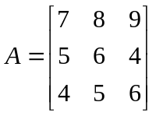 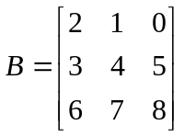  Find AB and BA.  OR  if A= 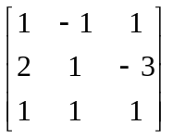 find A  - Show that  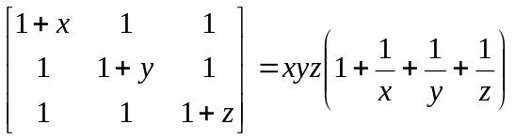 | 8  7
2. | - Find the radius, center and equation of the circle passing through the points (1,0), (2, -2), (3, 1)  - Find the vertices, foci, equation of directrices and length of latus rectum of the parabolas.  - 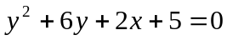  - 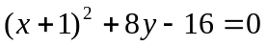 | 7  8
3. | Find 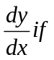  - 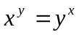  - x = cos (log t), Y= log (cost) | 8  7
4. | Find  (Any three) if  - 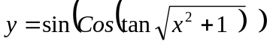  - 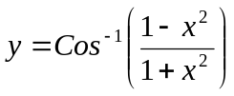  - 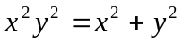  - y = 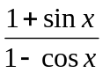 | 5x3
5. | Integrate (any three)  - 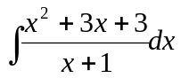  - 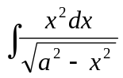  - 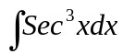  - 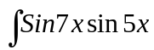 dx | 5x3
6. | Integrate  - 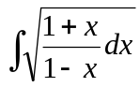  - 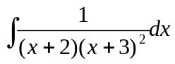 | 7  8
7. | Attempt all the questions.  - Expand 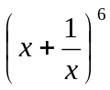  - Find the length of perpendicular drawn from (2,3) to the line.  8x + 15 y +24 = 0  - Integrate 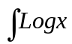 dx  - Find the sum of  - How many numbers between 4000 and 5000 can be formed with the digits 2, 3, 4, 5, 6, 7 ? | 2x5

